Temperature Alarm System

High-Level Design (HLD)

Version: 1.0
Date: 23-01-2026
Prepared by: Sreelakshmy M A

1. Purpose
The purpose of this document is to describe the high level design of the temperature alarm project. It includes the overview of the system , key components, high-level architecture diagram, software architecture with module wise data&control flow and their interactions. It also describes APIs, inter process communication methods and data exchange formats with error handling and fault handling mechanisms required to detect temperature variations and trigger alarms when thresholds are exceeded.

2. System Overview

2.1 Introduction
The Temperature Sensor Alarm system provides continuous monitoring of temperature readings. It operates by regularly (every TEMP_READ_FREQUENCY milliseconds) reading the temperature and evaluating it against predefined threshold limits (TEMP_THRESHOLD_MIN to TEMP_THRESHOLD_MAX). If a reading falls outside this acceptable range, the system triggers an alert by printing the message “Alarm Triggered.” If the temperature remains within the limits, no message is printed. This continuous cycle of reading and evaluation runs indefinitely, ensuring constant vigilance for alarm conditions.
Parameters | Description | Value
TEMP_THRESHOLD_MIN | Minimum threshold temperature limit | -10°C
TEMP_THRESHOLD_MAX | Maximum threshold temperature limit | 50 °C
TEMP_READ_FREQUENCY | Sensor polling frequency | 20 ms
THRESHOLD_DETECTION_COUNT | Threshold breach limit | 5
ALARM_DURATION | Duration of Alarm | 10 ms
READ_RETRY_COUNT | Retry sensor read once failed | 5

2.2 Key Components

2.2.1 Temperature Read Module
This module is responsible for continuous temperature monitoring. It reads temperature values every TEMP_READ_FREQUENCY milliseconds. After validating the readings, the processed data is then sent to the Temperature Threshold Check module.

2.2.2 Temp Threshold Check Module
The module performs temperature validation, comparing readings from the Temperature Read module against the established range (TEMP_THRESHOLD_MIN to TEMP_THRESHOLD_MAX). If the readings fall outside these bounds for a consecutive period defined by THRESHOLD_DETECTION_COUNT, the Alarm module is triggered.

2.2.3 Alarm Module
When this module is activated it will print the message: "Alarm Triggered" and will last ALARM_DURATION milliseconds.

2.3 High level architecture diagrams

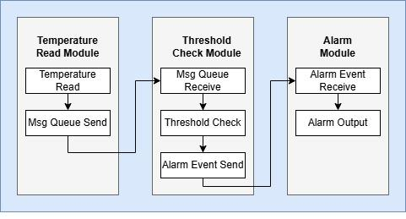

3. Software Architecture

The Temperature Alarm System comprises three main threads responsible for core functionalities:

1. Temperature Reading Thread:
- This thread's sole purpose is to read the temperature value at regular intervals defined by TEMP_READ_FREQUENCY.
- The acquired temperature data is then placed into a message queue for consumption by the threshold checking thread.

2. Temperature Threshold Checking Thread:
- Operating in a blocking mode, this thread continuously waits for and receives temperature data from the message queue.
- Upon receipt, the temperature is immediately compared against the acceptable operating range defined by TEMP_THRESHOLD_MIN and TEMP_THRESHOLD_MAX.
- If the temperature falls outside these limits, the alarm thread is activated using an event triggering mechanism.

3. AlarmThread:
- It waits for an alarm event to be activated.
- Once triggered by the threshold checking thread (when a temperature violation is detected), it prints the corresponding notification.
- The alarm remains active for ALARM_DURATION milliseconds before the thread returns to its waiting state for the next alarm event.

4. Module Descriptions

4.1 Temperature Read Module
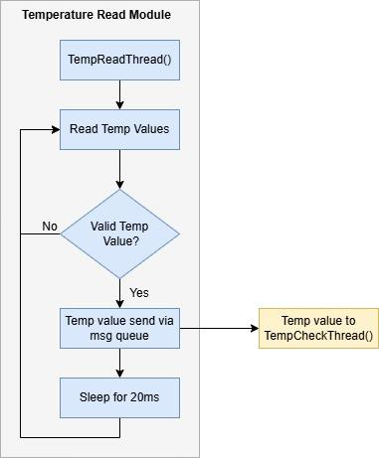

4.2 Temp Threshold Check Module
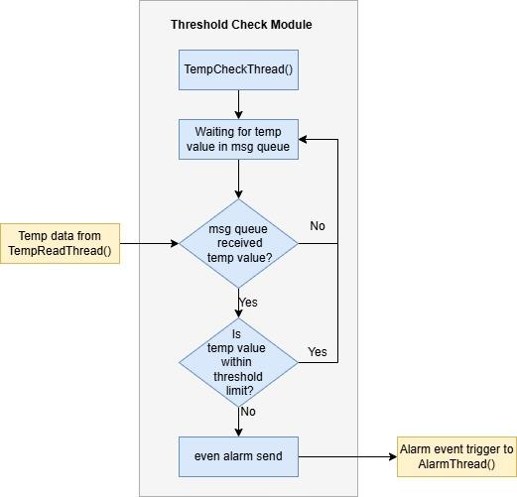

4.3 Alarm Module
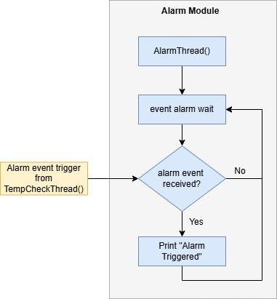

5. Interface Design

5.1 Application Programming Interface(API)
API | Description | Parameters
void TempReadThread(void *arg) | Read and Validate Temperature: Obtain the temperature reading from the sensor and perform necessary validation.  Queue Temperature Value: Enqueue the validated temperature value into the sensor message queue.  Send to Threshold Checking Thread: The temperature value is sent to the TempCheckThread() via the sensor message queue.
void TempCheckThread(void *arg) | Wait for Temperature Value: This thread waits in a blocking mode for the temperature value from TempReadThread() via a sensor message queue.  Check Threshold Limits: The received temperature value is compared against the predefined limits TEMP_THRESHOLD_MIN and TEMP_THRESHOLD_MAX.  Activate Alarm: If the temperature value falls outside the acceptable range (below the minimum or above the maximum), AlarmThread() is activated using an alarm event mechanism.
void AlarmThread(void *arg) | Wait for Alarm Event: This thread is responsible for waiting for the alarm activation event signaled by the TempCheckThread().  Alarm Trigger Action: Upon receiving the event, it will print the message "Alarm Triggered" and remain active for the duration defined by ALARM_DURATION.

6. Data Flow
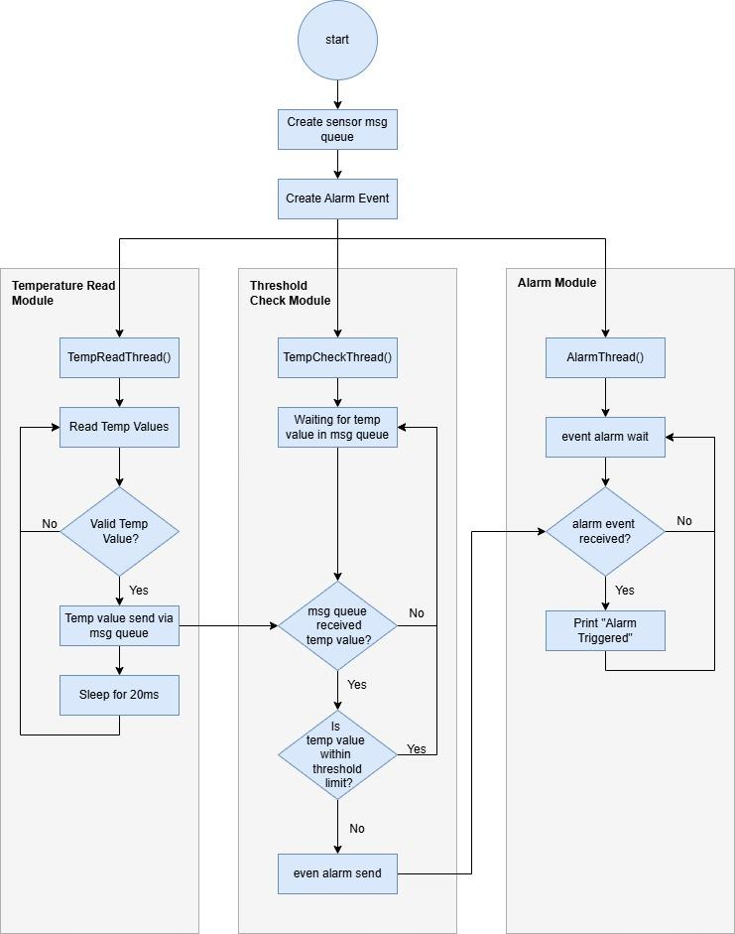

7. Error Handling & Fault Management

7.1 Message queue failures
Detects queue transmission failures using return codes and timeouts.

7.2 Temperature value validation
Detect invalid temperature read using proper logic and error codes

7.3 APIs failure check
Use error codes to detect failure for all APIs

8. Traceability

